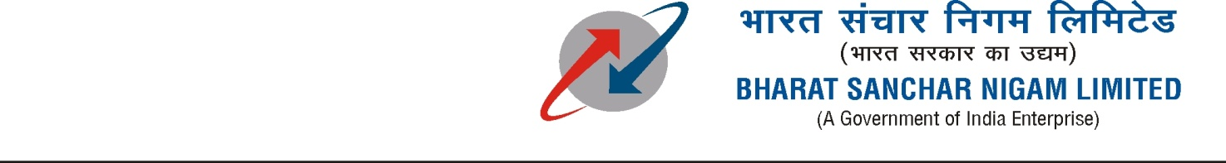
O/O Deputy General Manager (C&A) NP
E6, 3rd Avenue, Anna Nagar East,
Chennai – 600 102.

E-TENDER No. DGM(C&A)NP / Cable Fault Mtce & Rehab / 2019-20 /01 Dated 08-08-2019
E-TENDER FOR CABLE MAINTENANCE (INCLUDING CABLE JOINTING FOR ATTENDING U/G CABLE FAULTS) AND REHABILITATION WORKS IN ANNANAGAR AREA OF BSNL CHENNAI TELEPHONES

Tender Submission extended:

Date & Time of Submission of e-Tender bid:
Last Date/ Time of submission of e-Bid Online: up to 11.00 HRS of 04-10-2019.
Last Date/Time of Submission of documents in hard copy(Offline) :up to 11-30 HRS of 04-10-2019.
Online opening of Tender e-Bids: At 12.00 HRS of 04-10-2019.

SDE TECH NP

